Tutorial week 4 task:

Task 1:

Player wins:
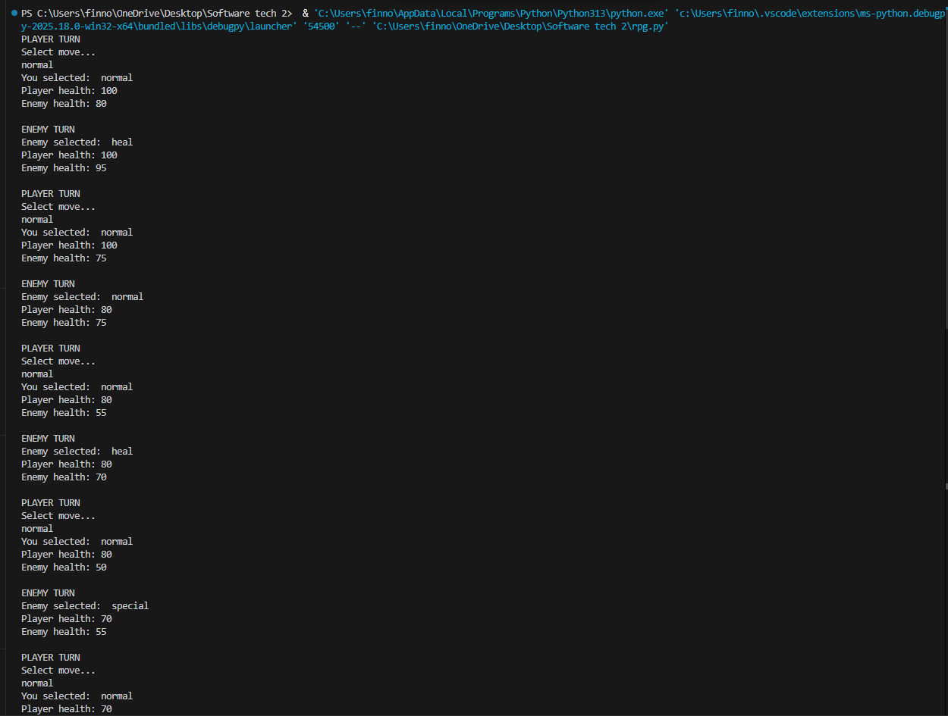
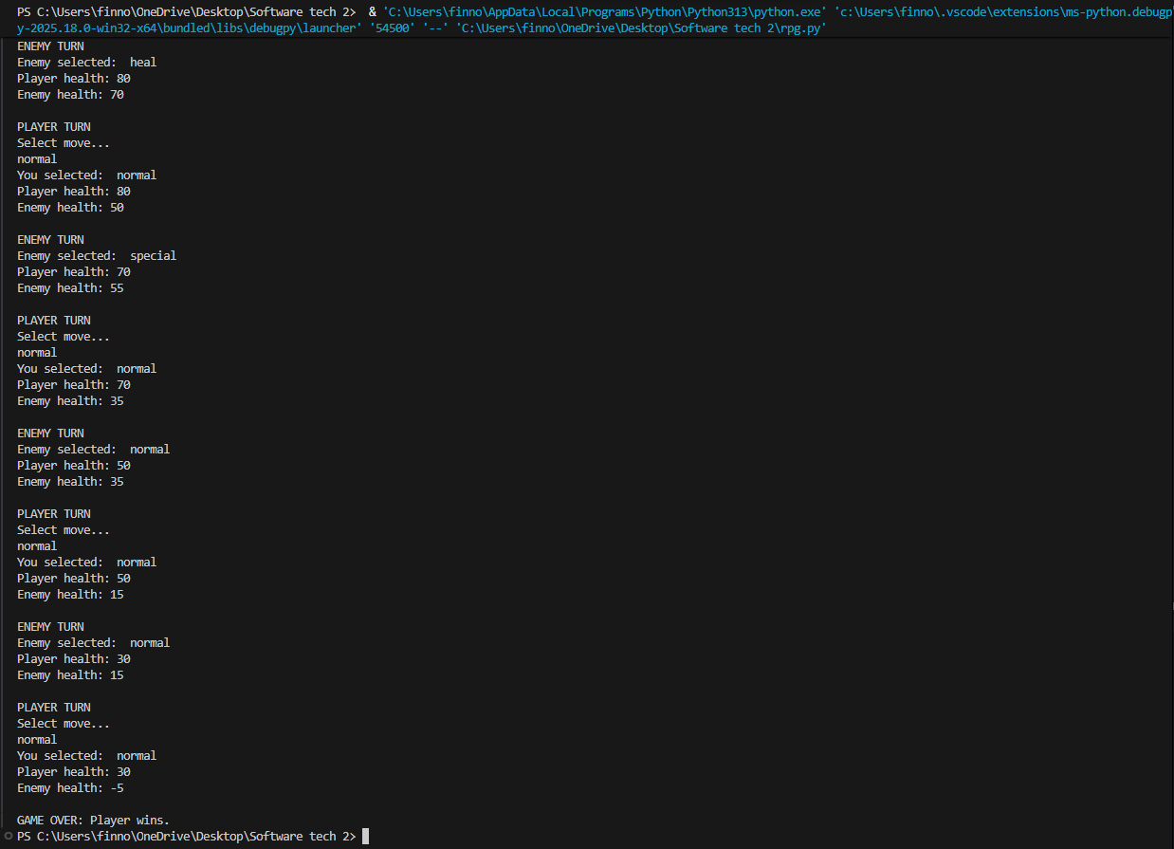

Player draws:
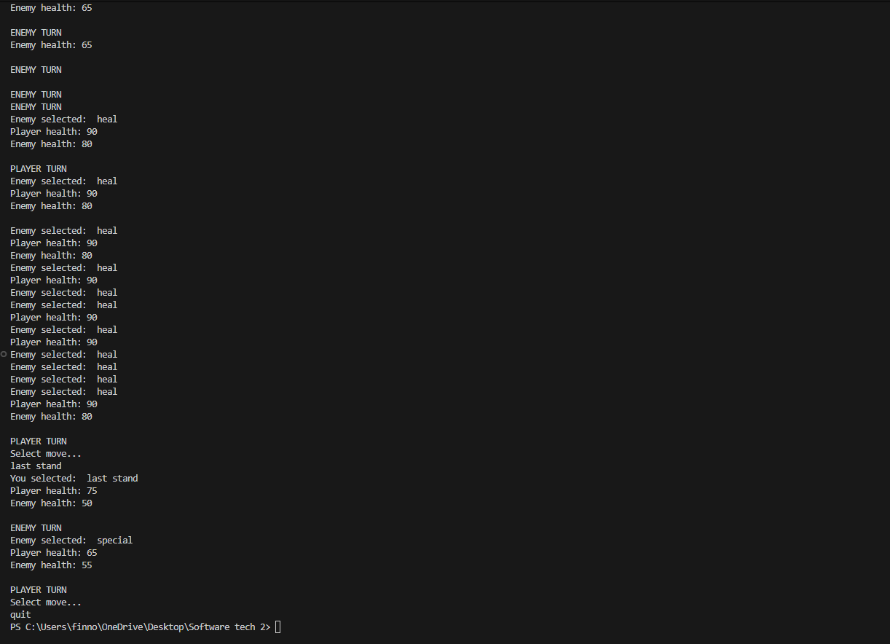

Player losses:
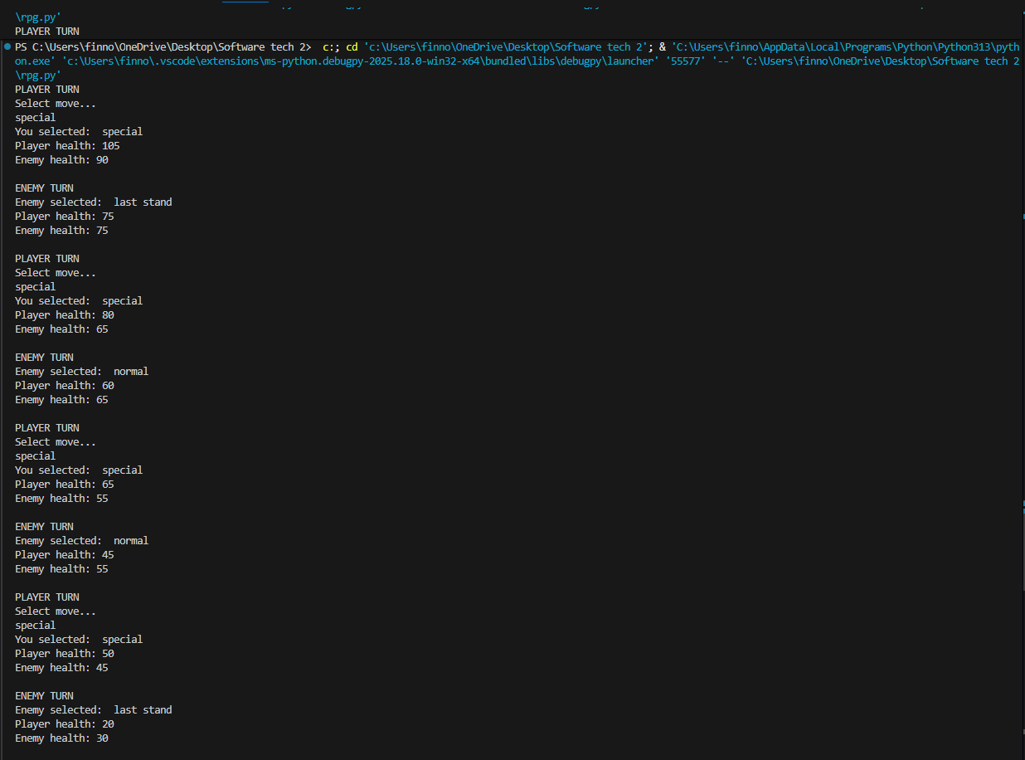


Testing Q2 - Q4

Low range large data set:


High range large data set:
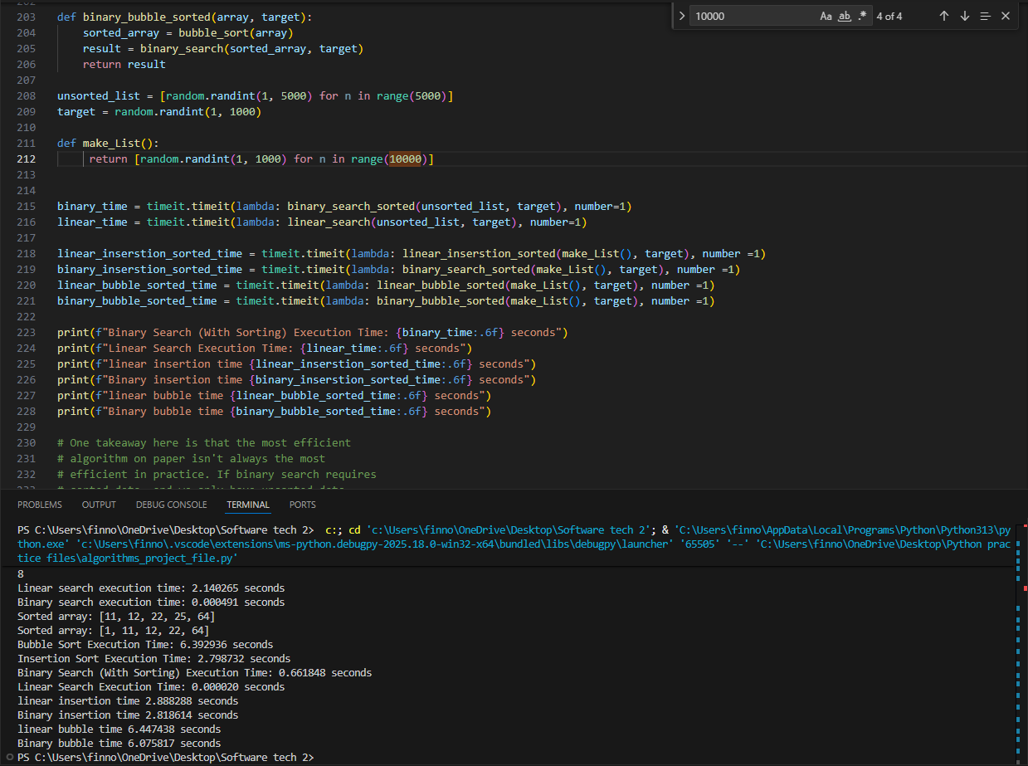

Larger range smaller data set
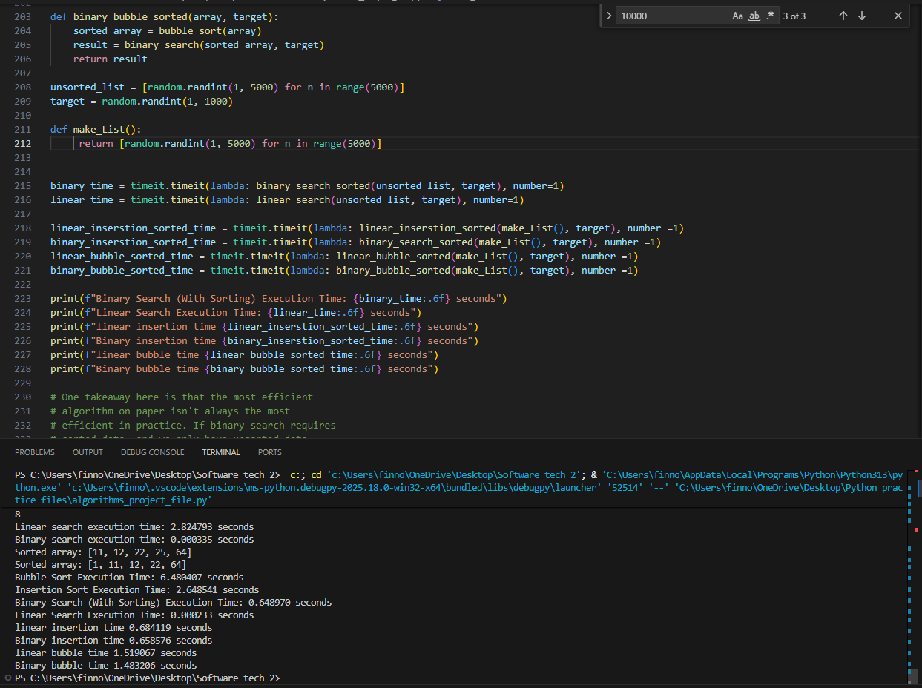

Low Range Low Data set
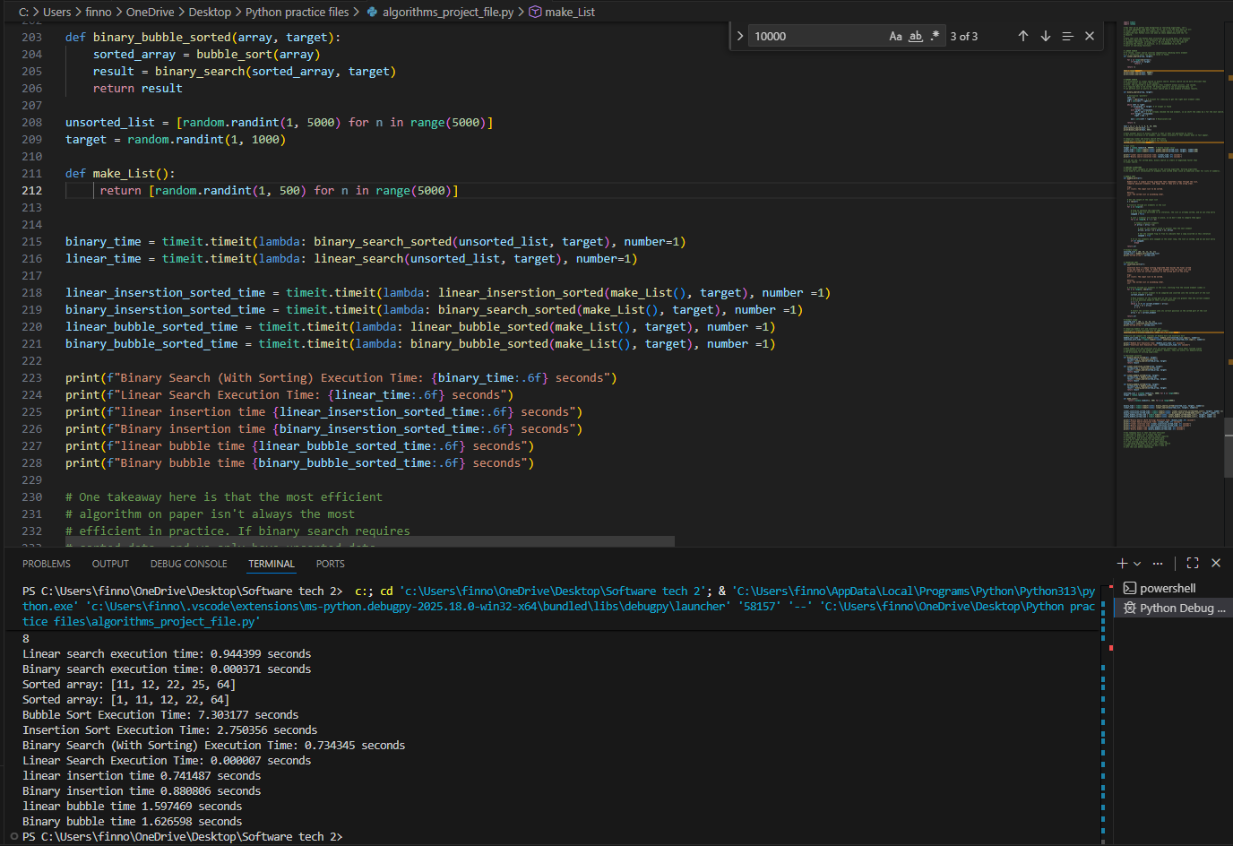

Q2 explanation:
Binary search is much quicker as it removes half the data set via each iteration until the item is found. Linear search algorithm is far less efficient than a binary search algorithm as it goes through every item in the data set sequentially making it better for smaller data sets.

Data set size
As the data set increases in size the disparity between linear and binary search increases. This is because linear search in set at On time complexity as it must iterate through each value whereas binary search is Ologn as increased data set size only means a few additional iterations.

Range:
When there is a lower range of potential numbers within the data set linear search becomes more competitive as there are a higher number of duplicate elements meaning in practice that the element that is needed is scaterrred multiple times throughout the set and more likely to be at the start.

Q3 Explanation:
Within this program the Insertion sort search algorithms perform considerably faster than the bubble search algorithm due to the reason number of iterations.

Range:
The bubble sort algorithm where much closer in speed to the linear sorting algorithm when the range was low. This is mostly due to a higher level of duplicate values within the data set meaning that the bubble set was able to iterate over many of the values without swapping them as they where equal.

Data set size:
As data set size increased the insertion algorithm became clear faster and more efficient. This is because as the data set got larger the outcomes became more likely leading to the more efficient algorithm (insertion algorithm) clear becoming faster. Additionally, the previously established. As a bubble algorithm must repeatedly sort over the data set it increased at a far more exponential rate than the insertion algorithm which still only must iterate over the set once giving it on time complexity.

Q4 Explanation:
The sorting algorithms tend to take considerably longer than then the search algorithms as the searching algorithms need to locate one value whereas the sorting algorithms must sort through every value in the data set. This means that both the linear and binary insertion algorithms where considerably quicker with the binary being the quickest. The difference was at the smallest between each when the range and data set where at the smallest this was because the bubble algorithm and linear algorithms where far more effective at the lower ranges and smaller data sets. Whereas the opposite was true for higher data sets and ranges.

